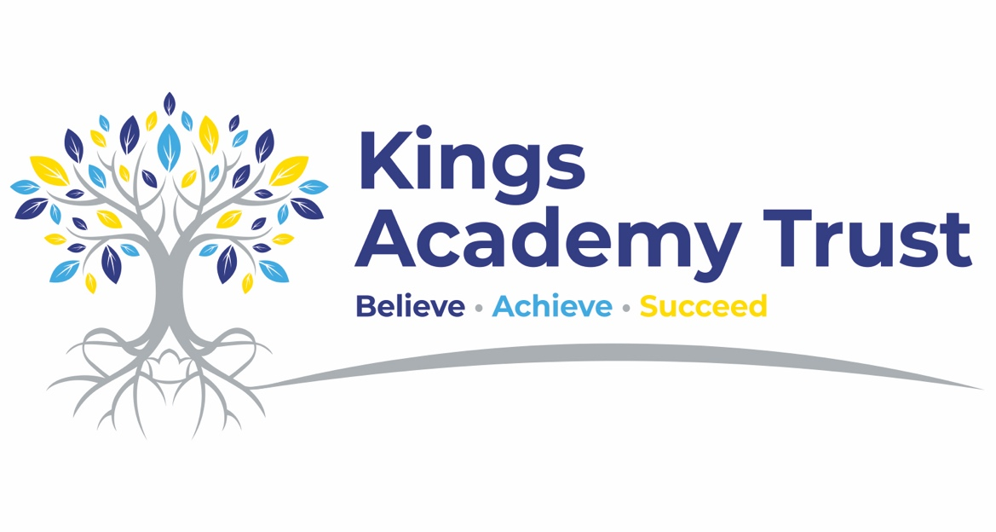

Primary School Cover Supervisor

Salary: NJC Scale 23 – 28 ( £34,450 - £39,171 FTE) Pro Rated for Term time Only
Contract: Full time, permanent, term time only plus 5 days
Closing date: 9am 8th July
Interviews: Week comm 13th July
Starting date: September 2026

Kings Academy Trust is seeking to appoint a committed, confident and enthusiastic Primary School Cover Supervisor to support high-quality learning across our primary provision. This role may involve working across two of our trust schools, or within Willows Primary, our primary provision attached to Oakwood Academy.

This is an exciting opportunity for someone who is passionate about supporting children’s learning and enjoys working in a varied, purposeful and nurturing school environment. The successful candidate will provide cover for classes during teacher absence or planned release time, ensuring pupils remain engaged, supported and able to continue their learning.

Working closely with teachers and school leaders, you will deliver planned learning activities, manage classroom routines, support pupils’ behaviour and engagement, and help create a positive learning environment. You will need to be adaptable, calm, well-organised and able to build positive relationships with pupils and staff.
This role is ideal for someone with experience of working with children in a primary school setting who is confident leading whole-class learning using plans and resources prepared by teaching staff.

We are looking for someone who is patient, resilient and enthusiastic, with a strong commitment to inclusion, safeguarding and helping pupils achieve their best.
Key responsibilities
• Supervise whole classes during the short-term absence of teachers or during planned cover.
• Deliver learning activities and ensure pupils remain focused and engaged.
• Support pupils with their learning, including individuals and small groups where needed.
• Promote positive behaviour, routines and relationships in line with school policies.
• Adapt support to meet pupils’ needs, including pupils with SEND.
• Provide feedback to teaching staff about pupil engagement, progress and any issues arising during cover.
• Support the wider life of the school, including transitions, breaktimes, lunchtimes and enrichment activities where required.
• Work collaboratively with teachers, teaching assistants, pastoral staff and school leaders.
We are looking for someone who:
• Has experience working with children in a primary school or similar educational setting.
• Is confident leading learning with a whole class using plans provided by teachers.
• Can build positive, respectful relationships with pupils.
• Has strong behaviour management skills and a calm, consistent approach.
• Is flexible and able to work across different classes, year groups or school settings.
• Understands the importance of inclusion and meeting individual needs.
• Works well independently and as part of a team.
• Is committed to safeguarding, pupil wellbeing and supporting positive outcomes for children.
We can offer:
• A welcoming and supportive trust with a strong commitment to staff development.
• The opportunity to work within nurturing primary school environments.
• A collaborative team culture where relationships, inclusion and staff wellbeing are prioritised.
• High-quality professional development and support.
• The opportunity to make a meaningful difference to children’s learning, confidence and school experience.
• A varied and rewarding role across primary provision within Kings Academy Trust.

How to apply
Application forms, along with a covering letter, should be emailed to jwhiteley@kingsacademytrust.co.uk

If you require a paper copy of the application form or this information in Microsoft Word format, please contact jwhiteley@kingsacademytrust.co.uk

Safeguarding
Kings Academy Trust is committed to safeguarding and promoting the welfare of children and young people. All posts are subject to an enhanced DBS check and satisfactory references. We welcome applications from all sections of the community.

