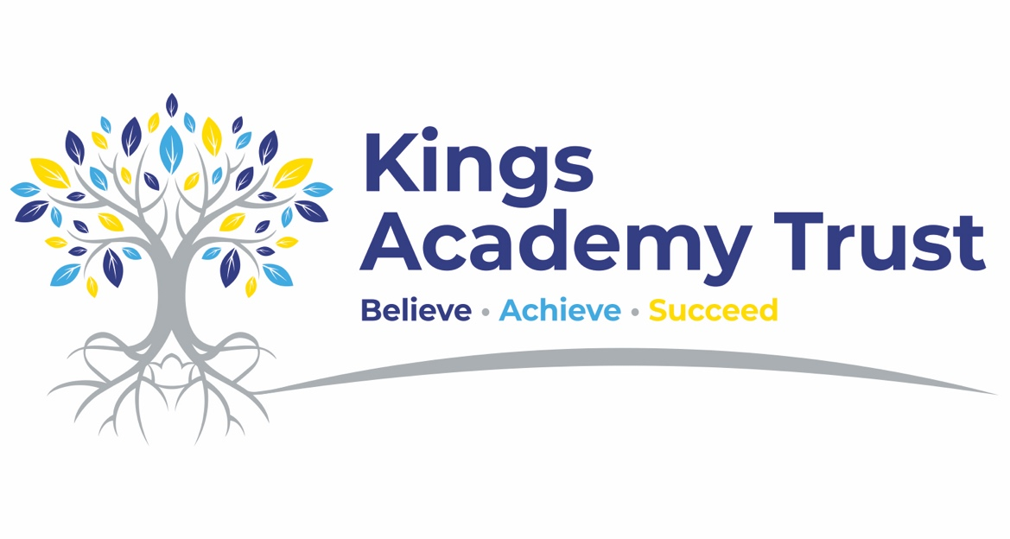

Secondary SEND Cover Supervisor

Salary: NJC Scale 23 – 28 (£34,450 - £39,171 FTE) Pro Rated for Term time Only
Contract: Full time, permanent, term time only plus 5 days
Closing date: 9am 8th July
Interviews: Week comm 13th July
Starting date: September 2026

Kings Academy Trust is seeking to appoint a committed, confident and enthusiastic Secondary SEND Cover Supervisor to support high-quality learning across our secondary specialist provision. This role will involve working across Oakwood Academy, Acer Academy and Arbour Academy, supporting pupils with a range of additional needs.

This is an exciting opportunity for someone who is passionate about supporting young people’s learning and enjoys working in varied, purposeful and nurturing school environments. The successful candidate will provide cover for classes during teacher absence or planned release time, ensuring pupils remain engaged, supported and able to continue their learning.

Working closely with teachers, teaching assistants and school leaders, you will deliver planned learning activities, manage classroom routines, support pupils’ behaviour and engagement, and help create a positive learning environment. You will need to be adaptable, calm, well-organised and able to build positive relationships with pupils and staff across different school settings.
This role is ideal for someone with experience of working with children or young people, particularly those with SEND, who is confident leading whole-class learning using plans and resources prepared by teaching staff.

We are looking for someone who is patient, resilient and enthusiastic, with a strong commitment to inclusion, safeguarding and helping pupils achieve their best.
Key responsibilities
• Supervise whole classes during the short-term absence of teachers or during planned cover.
• Deliver learning activities and ensure pupils remain focused and engaged.
• Support pupils with their learning, including individuals and small groups where needed.
• Promote positive behaviour, routines and relationships in line with school policies.
• Adapt support to meet pupils’ needs, including pupils with SEND, SEMH needs and communication difficulties.
• Provide feedback to teaching staff about pupil engagement, progress and any issues arising during cover.
• Support the wider life of the school, including transitions, breaktimes, lunchtimes and enrichment activities where required.
• Work collaboratively with teachers, teaching assistants, pastoral staff, therapeutic staff and school leaders.
We are looking for someone who:
• Has experience working with children or young people in a school or similar educational setting.
• Has an understanding of SEND and the barriers some pupils may face in accessing learning.
• Is confident leading learning with a whole class using plans provided by teachers.
• Can build positive, respectful relationships with pupils.
• Has strong behaviour management skills and a calm, consistent approach.
• Is flexible and able to work across different classes, year groups and school settings.
• Understands the importance of inclusion and meeting individual needs.
• Works well independently and as part of a team.
• Is committed to safeguarding, pupil wellbeing and supporting positive outcomes for young people.
We can offer:
• A welcoming and supportive trust with a strong commitment to staff development.
• The opportunity to work within nurturing secondary SEND and specialist school environments.
• A collaborative team culture where relationships, inclusion and staff wellbeing are prioritised.
• High-quality professional development and support.
• The opportunity to make a meaningful difference to pupils’ learning, confidence and school experience.
• A varied and rewarding role across secondary specialist provision within Kings Academy Trust.

How to apply
Application forms, along with a covering letter, should be emailed to segan@oakwoodacademy.co.uk

If you require a paper copy of the application form or this information in Microsoft Word format, please contact segan@oakwoodacademy.co.uk

Safeguarding
Kings Academy Trust is committed to safeguarding and promoting the welfare of children and young people. All posts are subject to an enhanced DBS check and satisfactory references. We welcome applications from all sections of the community.

