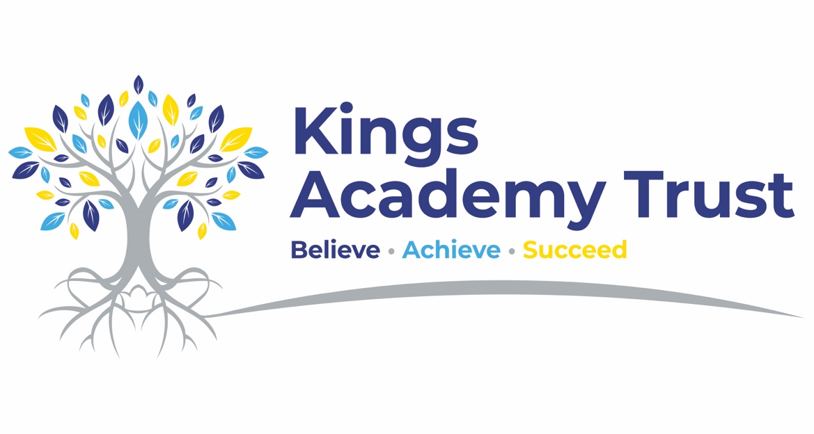

Flexible Working Policy

Policy created: September 2025

Approved by Trust Board/ (Date TBC)

Due for review: September 2026

Contents
Page
1. Introduction 3 2. What the Law says 4 3. Flexible Working – what exactly is it? 4 4. Requesting a Flexible Working Arrangement 4 5. Headteacher Considerations 5 6. Key contacts 5
8. Flexible Working Request Form 6 & 7

2

1. Introduction
Kings Academy Trust encourages all employees to have a healthy work / life balance. It is therefore committed to providing the working pattern and environmental facilities that allow employees to work flexibly, whilst also meeting changing customer demand for service delivery.
The policy enables all employees to have the right to flexible working, subject to the type
of work being undertaken and demands of the service.
Flexible working can provide significant benefits such as:
• increasing staff morale and satisfaction levels
• reduction in sickness absence
• an improved work life balance so that staff have more time to spend with their families or personal commitments
• retaining valuable staff
In developing a flexible workforce Kings Academy Trust recognises the importance of supporting employees to balance the work and home life.
With an increasing diverse workforce, domestic and family commitments have shifted. In aging population has meant more people are working for longer and employees are increasingly becoming carers for older relatives.
Kings Academy Trust is committed to attracting, developing and retaining an exemplar workforce. It aims to deploy all the talent and experience available in the most flexible and efficient manner and prides itself in being an exemplar employer. Flexible working is a benefit to employees and supports the vision for effective health and wellbeing support in the workplace and to articulate how Kings Academy Trust aims to put its people at the heart
of everything it aims to achieve.
Flexible working involves a range of different working arrangements which allow employers and employees to utilise non-traditional working patterns. These patterns enable an employer to meet service demands more effectively and help employees to balance work, home and personal priorities.
Different flexible working patterns will be more or less suited to particular service areas and types of working.
The policy shall apply to all staff employed by Kings Academy Trust.
Accordingly, all employees must familiarise themselves with the policy.
This policy does not form part of any employees’ contract of employment, and it may be amended at any time and in consulation with recognised Trade Unions.

3

2. What the law says
Under provisions set out in the Employment Relations (Flexible Working) Act 2023 and regulations made under it, all employees have a statutory right to ask their employer for a change to their contractual terms and conditions of employment to work. An employee can make two statutory requests in any 12-month period.
To find out more about what the law says about Flexible Working, please visit: Flexible working: Overview - GOV.UK (www.gov.uk).
The policy however does not apply to workers, contractors’ consultants or any self- employed individuals working for the organisation.
3. Flexible Working – What exactly is it?
We are passionate about creating an inclusive culture that supports a good work life balance; putting our employee’s health and wellbeing at the fore and investing in an
environment where employees can thrive.
Flexible working can provide significant benefits to both employees and employers by allowing changes to an employee’s standard working pattern. Flexible working supports employees managing the demands of home and work and responds to changing circumstances either at home or work or both. Or even may contribute to the
organisations environmental initiatives reducing the need for travel and/or energy consumption during certain periods of the day or week.
Flexible working is specifically about changes to:
• the number of hours worked
• when they start or finish work
• the days they work
- Work location (Hybrid WFH)
3.1. Why consider it?
There is evidence that flexible working increases staff morale. Employees are also more likely to be committed to an employer that accommodates their working pattern. Employees also have a greater sense of ownership and control of their working lives and have an improved sense of well-being. It can also assist in managing stress as a result of employees having more time to focus on their outside work.
4. Requesting a Flexible Working Arrangement
You can submit two flexible working requests in any 12-month period. This request will be considered to change the contractual terms and conditions of employment to allow a staff member to work flexibly and therefore agreement between both parties is required.
Requests for flexible working arrangements must be made by completing the form found at Appendix 1.Once you have completed the form, please send to your Headteacher or Head of School, this is likely to be when your application date starts.

4

5. Considerations
All flexible working requests need to be considered in consultation with the staff member and should take no more than two months to be concluded from the initial application date.
Each request should be considered on a case-by-case basis weighing up:
• The potential benefits to both the employee and the organisation
• Any adverse impact of implementing these changes
It must be noted that agreeing to once request will not set a precedent or create a right for another employee to be granted a similar change to their working patterns.
You may wish to grant the request in full or in part, for example:
• The organisation may propose a modified version of the request
• The request may be granted on a temporary basis
• The request may be requested to be trialled
There are set business criteria under which refusal must fall. Please see the Flexible Working Guidance document to follow and better understand the process for dealing with requests.

Appendix 1
Flexible Working Request Form
Please read the policy before proceeding

Information required | Complete all sections
Employee forename(s):
Employee surname:
Job Title:
Payroll number:
Email:
School:
Current working hours:
Current working pattern:
Number of hours in new working pattern:
New pattern requested:
Temporary or permanent variation  (tick one box): | ☐ Permanent  ☐ Temporary:  • please give expected end date:  • please give expected review date:
Proposed effective date:
Reason for request:
(please supply as much detail as possible, so that your Headteacher/Head of School can give due consideration to your request)

6

Information required | Complete all sections
Is the request being made as a reasonable adjustment for a disability, under the Equality Act 2010? | Yes / No  (if yes, please indicate how the adjustment will help you)
Employee signature:
Date signed:
Please return to your Headteacher/Head of School.

